Autonomous Mobile Robot for mapping using Ultra-Sonic Sensors and Python

Rodrigo Oliveira, nº1231491

Contents

Figure index 2

Introduction 3

State of the art 3

Requirements 4

High level architecture 5

Hardware choice 6

2D sensors 6

Motors & encoders 6

Microcontroller 7

Batteries and Voltage Regulator 7

Optimizations 7

3D model 8

Detailed Architecture 9

References 10

# Figure index

Figure 1- High level architecture 5

Figure 2 - Render 1 of the robot 8

Figure 3 - Render 2 of the robot 8

Figure 4- Detailed architecture 9

# Introduction

Autonomous Mobile Robots (AMRs) are increasingly becoming essential in various fields, from industrial automation to home robotics. Their ability to navigate and operate independently in dynamic environments has opened numerous possibilities for their application.

This project aims to design and develop an AMR capable of autonomously mapping a 2D environment and navigating to specific locations within that mapped area. The goal is to create a cost-effective and efficient platform that demonstrates the potential of AMRs in real-world scenarios, with a focus on usability and accessibility.

# State of the art

To determine the best approach for developing our project, it's important to understand the current state of available technologies. To achieve this, we have decided to create a comparison table that organizes the existing solutions based on their suitability for our goals, as presented in Table 1.

Before creating the table, we must first define the key parameters for our project. The robot platform should be low-cost and feature Wi-Fi capabilities to enable remote communication and data transmission. Since the objective is to map a given area, the robot will require at least two motors equipped with encoders to gather positioning data, which is essential for the mapping process. Additionally, the robot must be equipped with distance sensors to measure the proximity of objects, ensuring accurate environmental mapping. Finally, the platform should be battery-powered for mobility and ease of use in different environments.

Table - Market analysis

|  |  |  |  |  |
| --- | --- | --- | --- | --- |
|  | TurtleBot 4 [1] | Hiwonder [2] | Kitronik [3] | JetBot Pro [4] |
| Motors | 2 | 4 | 2 | 2 |
| Encoders | Yes | No | Yes | Yes |
| Wireless Communication | Wi-Fi | Wi-Fi | None | Wi-Fi |
| Sensors | LIDAR/Camera | US/Camera | US | LIDAR/Camera |
| Battery | Yes | Yes | No | Yes |
| Price [€] | 2200 | 225 | 37 | 450 |

The market study did not yield any satisfactory results, primarily because existing options either failed to meet our technical requirements or were priced outside of our budget. As a result, we decided to build our own platform.

# Requirements

The robot to be built has the goal of mapping a given area, to achieve this we must comply with the following requirements:

* It must be capable of reliably relaying the current position in relation to some point, and current angle
* It must be Wi-Fi enabled in order to be controlled by an outside device
* It must be battery powered so that the robot may be fully autonomous
* It must be cheap

# High level architecture

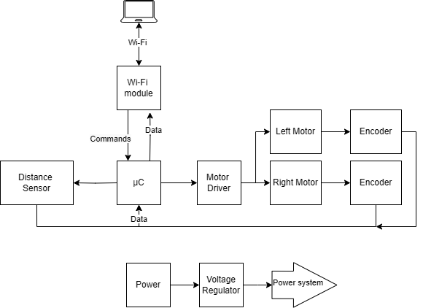

Figure - High level architecture

# Hardware choice

The material chosen below, even if not the best available, is what was available at the time of writing and therefore was what was chosen.

## 2D sensors

|  |  |  |  |  |
| --- | --- | --- | --- | --- |
|  | Range [m] | Resolution [mm] | Frequency [Hz] | Price [€] |
| HC – SR04P | 0.02 to 4 | 3 | 40 | 3.7 [5] |
| TFmini-S | 0.3 to 12 | 10 | 100 | 41 [6] |
| RPLIDAR A1M8 | 0.15 to 12 | 1% | 10 | 114 [7] |

For the 2D sensor it was chosen to use the Ultra-sonic sensor - HC-SR04P. As previously mentioned, we will employ four of these sensors to minimize the drawbacks of using them.

## Motors & encoders

|  |  |  |  |  |  |  |
| --- | --- | --- | --- | --- | --- | --- |
|  | RPM | Voltage [V] | Current [mA] | Type of encoder | Steps per rev | Price [€] |
| JGA25-370 DC | 170 | 6 | 200 | Magnetic | 22 | 9.6 [8] |
| N20 Gear Motor | 75 | 6 | 70 | Magnetic | 14 | 17.84 [9] |
| EMG30 | 170 | 12 | 200 | Magnetic | 11 | 45.82 [10] |

For the motors it was chosen to use the JGA25-370DC as it was the cheapest and the best equilibrium between the cost and quality. The Steps per rev refers to the resolution of the encoder. However, it is notable that this motor has a gear box, as such, these refer to motor revolutions and not shaft revolutions, making it far more precise than it appears.

## Microcontroller

|  |  |  |  |  |  |
| --- | --- | --- | --- | --- | --- |
|  | GPIO pins | Wi-Fi | Logic level 1 [V] | CPU [MHz] | Price [€] |
| Arduino Uno | 14 | NO | 5 | 16 | 11.97 [11] |
| ESP-32 | 34 | YES | 3.3 | 240 | 5.28 [12] |
| Raspberry-pi Pico | 26 | NO | 3.3 | 133 | 6.9 [13] |
| Teensy 4.0 | 40 | NO | 3.3 | 600 | 37.4 [14] |

Since the chosen motor is a 6V motor, the selected microcontroller must support this voltage. The Arduino Uno, based on the ATMEGA328P, fits this requirement. Although a motor driver will be necessary to handle the required currents, no additional voltage regulation will be needed for the microcontroller itself.

However, as mentioned earlier, the Arduino Uno lacks Wi-Fi capabilities. To address this, we will use an ESP-32, based on the dual-core Tensilica LX6, as a Wi-Fi relay. While the ESP-32 will require a 5V voltage regulator and a level shifter to operate properly, this setup is still more straightforward than managing a motor driver with two voltage levels.

## Batteries and Voltage Regulator

The batteries selected for this project are the industry-standard 18650 batteries, which are among the most used batteries in robotics. Typically, these batteries have a nominal voltage of 3.7V, with power capacity varying by manufacturer. To ensure a longer continuous runtime, the robot will be equipped with four of these batteries. Additionally, a voltage regulator will be included to stabilize and manage the voltage supplied from the batteries to the system.

## Optimizations

Due to the limited number of GPIO pins on the Arduino Uno and the fact that each ultrasonic sensor requires four pins, a multiplexer will be used to select one sensor at a time. This approach reduces the total number of required pins from ten to seven, allowing for more efficient use of the available GPIO resources.

# 3D model

To plan the best approach for building the robot, I chose to fully model it in Fusion 3D, utilizing my familiarity with the software. This 3D model will help identify the optimal design, minimizing the need for reprinting the frame due to unforeseen changes. The final model dimensions are 205 mm in width, 175 mm in depth, and 124 mm in height.

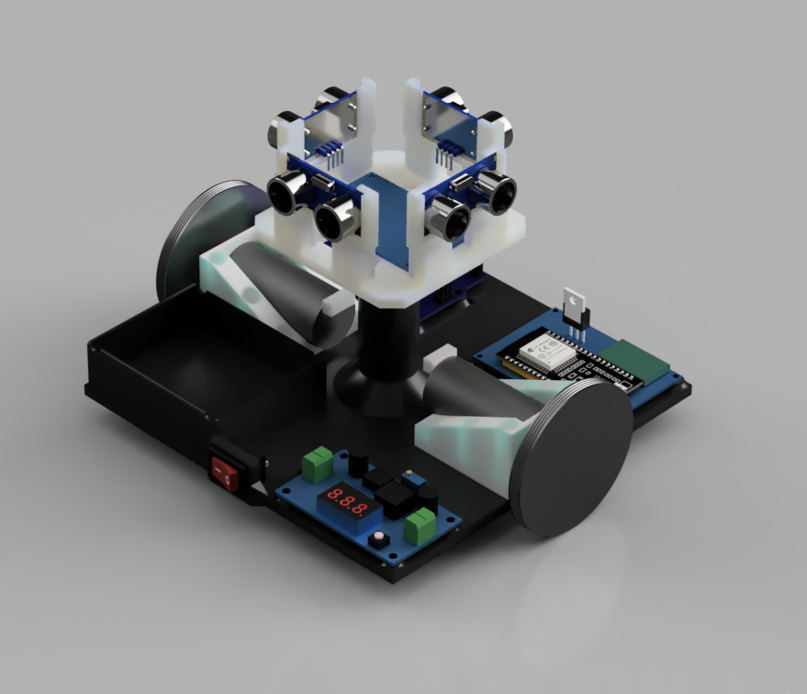

Figure - Render 1 of the robot

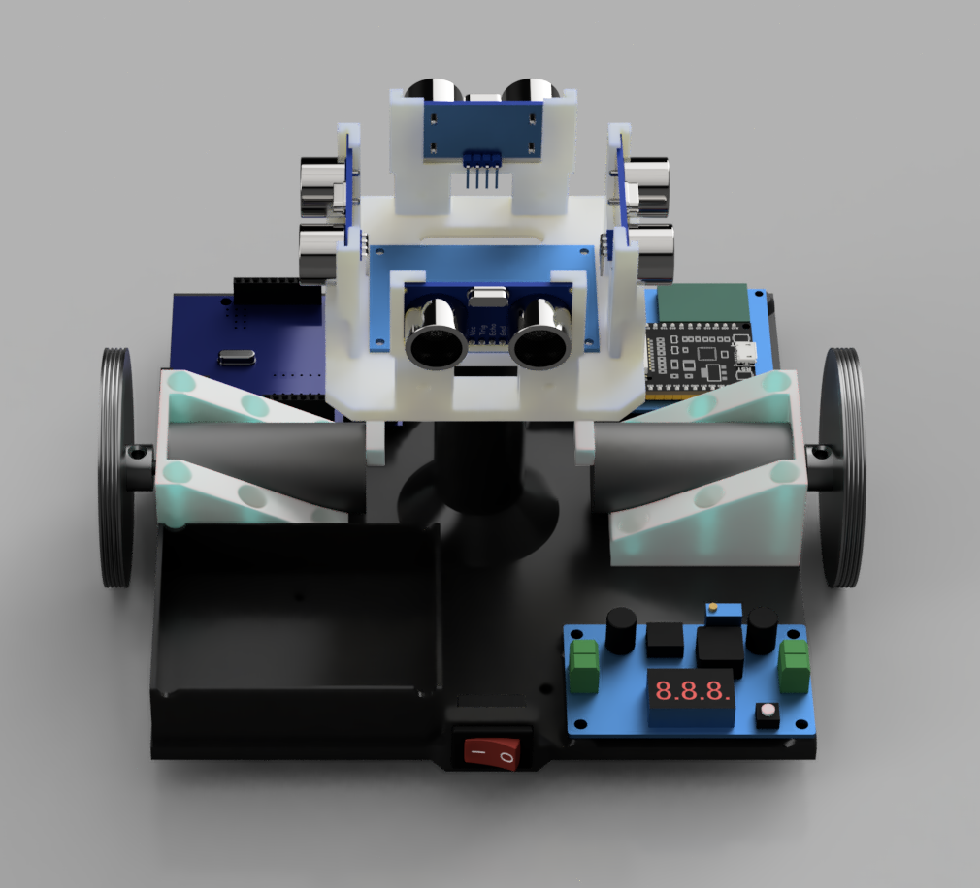

Figure - Render 2 of the robot

# Detailed Architecture



Figure - Detailed architecture

# References

|  |  |
| --- | --- |
| [1] | “Clearpath Robotics TurtleBot 4 Mobile Robot,” RobotShop, [Online]. Available: https://www.robotshop.com/products/clearpath-robotics-turtlebot-4-mobile-robot. [Acesso em 12 10 2024]. |
| [2] | “Hiwonder TurboPi Raspberry Pi Omni Mecanum Wheels Robot Car Kit w/ Camera Open Source Python for Beginners (w/ RPi 4B 4GB),” RobotShop, [Online]. Available: https://www.robotshop.com/products/hiwonder-hiwonder-turbopi-raspberry-pi-omni-mecanum-wheels-robot-car-kit-w-camera-open-source-python-beginners-w-rpi-4b-4gb. [Acesso em 12 10 2024]. |
| [3] | “Kitronik Autonomous Robotics Platform (Buggy) for Pico,” RobotShop, [Online]. Available: https://www.robotshop.com/products/kitronik-autonomous-robotics-platform-buggy-for-pico. [Acesso em 12 10 2024]. |
| [4] | “JetBot Pro ROS AI Kit Dual Controllers w/ Jetson Nano Dev Kit + TF Card & Reader,” RobotShop, [Online]. Available: https://www.robotshop.com/products/jetbot-ros-ai-kit-dual-controllers-waveshare-jetson-nano-dev-kit-tf-card. [Acesso em 12 10 2024]. |
| [5] | “HC-SR04P Ultrasonic Range Finder 3.3-5V,” PTrobotics, [Online]. Available: https://www.ptrobotics.com/sensor-ultrasom/7211-hc-sr04p-ultrasonic-range-finder-33-5v.html. [Acesso em 16 10 2024]. |
| [6] | “TFmini S Uart,” Mouser, [Online]. Available: https://pt.mouser.com/ProductDetail/Benewake/TFmini-S-Uart?qs=DPoM0jnrROXBvfO6mWli6w%3D%3D. [Acesso em 16 10 2024]. |
| [7] | “RPLIDAR A1M8-R6 - SLAMTEC SCANNER LASER 360º,” BotnRoll, [Online]. Available: https://www.botnroll.com/pt/outros/4814-rplidar-a1m8-r6-slamtec-scanner-laser-360.html. [Acesso em 16 10 202]. |